RMIT Classification: Trusted


(online examination equivalent-turnitin assessment)

COURSE CODE AND TITLE: COSC2652: User Centred Design

INSTRUCTIONS

This ‘examination’ is OPEN BOOK, meaning you can use sources from literature and/or the Internet. However you MUST correctly cite and reference all the sources you use, citations in text, and references at the end of the answer, using either Harvard, APA, or IEEE styles correctly. Your work will be checked for originality using Turn It In and other text anomaly detectors. Please use quotation marks to clearly typographically identify texts taken from other sources.

Whilst you CAN discuss your answers with other students, I strongly advise you not to share answers, or text directly. Doing so can lead you into a situation where you lose marks because it isn’t possible to determine the originality of your work…

May 2021: As RMIT campus will be closed to students, I will monitor email and Teams for comments, queries or questions. An automatic extension will be applied of the equivalent number of hours of any RMIT compulsory activities on Monday/Tuesday/Wednesday whilst this assessment is running. Please document as special circumstances below.

PLEASE COPY THE FOLLOWING TABLE INTO YOUR ANSWER FILE:
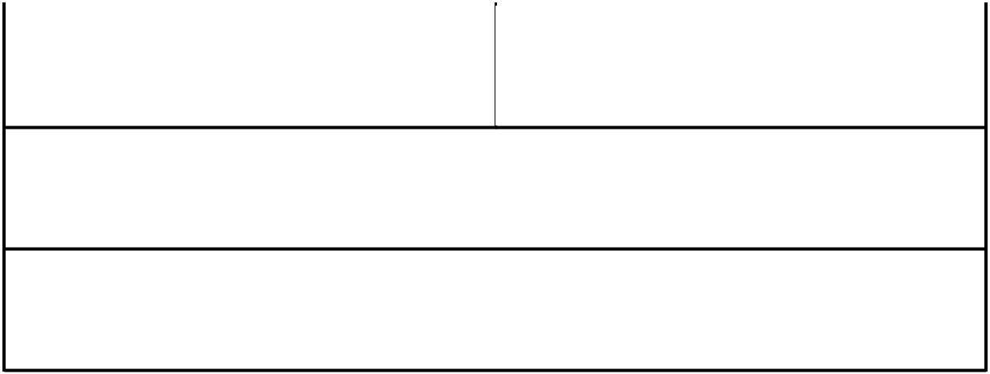

Candidate’s Family Name: |  |  | Candidate’s Given Name(s):
Candidate’s Student No.:

Any special circumstances e.g. other RMIT study activity taking place during the assignment period, please include: Course Name; Code; Staff Member name; Time and duration of the activity

Please indicate WHICH task (from A, B or C) you are going to do. (Also please identify each learning outcome in your answer, keep each learning outcome distinct).

There are 6 Learning Outcomes in this course. I’d like you to choose ONE of the following TASKS and apply it to all 6 learning outcomes.

EITHER

Task A: Write a guide to success in the course for future students. You are asked to identify the most important concepts, in EACH learning outcome for their peers to learn in the future, why those concepts are important, and how they are related to one another. This kind of
RMIT Classification: Trusted

assessment tests a student’s ability to prioritize information, communicate what they have learned, and to share the relationships between a range of course topics and content.

OR

Task B: Write ONE exam question for each Learning Outcome, and a marking scheme based on the RMIT scheme (HD, Di, Cr, Pass, Fail) By asking you to write their own exam questions, I am offering you an opportunity to engage in synthesis and identify the most important elements of the course.

OR

Task C: In your first job after completing your degree you are asked by your manager to write a description of the things you learnt about user centered design. He is doing this to see what you learnt and also to see if there are any interesting opportunities for the organization you have joined. In the first part of this answer, tell me where you might be working in your first job.

UCD Learning Outcomes:

- analyse users’ needs, usability goals and user experience goals of a small-to-medium-sized software application

- understand the components of a design plan and apply user-centred design process from requirement gathering to user studies and evaluation
- critically analyse usability of sample interfaces and identify key features that make an outstanding user-centred interface, and evaluate the usability of a small-to-medium-sized software application
- create a ‘usability checklist’ that enhances the usability of a web or mobile application, in order to summarise and explain usability concepts, relevant alternatives, and decision recommendations to your peers and IT specialists

- apply software and paper prototyping tools to design user interfaces that take into account human capabilities and constraints, users’ needs, usability goals and user experience goals

- synthesise the design and evaluation of various components of user interface effectively in teams in and peer-review team members’ works and contributions.

